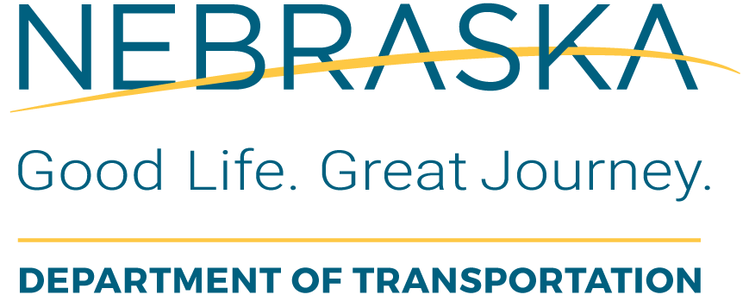 | Section 5339 Small Urban  Capital Grant Application  FY-  Bus and Bus Facilities

Bus/Vehicle Application

Funding is available through an apportionment from the Federal Transit Administration and administered by the Nebraska Department of Transportation. Applications can be submitted to NDOT at any time. Eligible applicants include public agencies or non-profit organizations engaged in public transportation. Prior to submitting an application, you are strongly encouraged to contact NDOT Transit Specialist at (402) 479-4674.

General Information
Legal Name of Applicant Organization:

Unique Entity Identifier (UEI)

Address (include City, State, and Zip Code):

Name of Project Director or Supervisor: | Phone No.: | Email Address:
Name of Person Preparing this Application: | Phone No.: | Email Address:
Services Generally Provided by Applicant:

Demographics
Ethnicity of Clientele | Service Area  Population | Percent of Total Service  Area Population
Black or African American |  | %
Hispanic or Latino |  | %
Native Hawaiian or other Pacific Islander |  | %
Asian |  | %
Native American or  Alaska Native |  | %
Non-Minority |  | %
Total |  | %
Transportation Project
Identify the Geographical Areas to be Served: (Towns, Counties)

Intended Use: (Check one)
Replace Existing Service Expand Existing Service Start New Service Enhance Existing Service

Capital Assistance
Vehicle(s) Requested
Prioritize  Vehicle(s)  Requested  (1, 2, 3) | No.  of  Units | Vehicle | Vehicle Cost | Total  Cost
 |  | Small Bus | $92,000 | $
 |  | Seven-Passenger Van | $70,000 | $
 |  | Lowered Floor Minivan | $65,000 | $
Total Costs: |  |  |  | $
Total Federal Funds requested (80% of total costs) |  |  |  | $
Local Share (20% difference between Federal funds requested and total costs) |  |  |  | $

Maintenance of Vehicles
To assure that vehicles acquired with Federal Transit Assistance funds are maintained in optimal operating condition, it is required that they be maintained in accordance with the vehicle manufacturer’s recommended maintenance schedule. Applicants must verify by certifying below.
Maintenance Certification
certifies that vehicles purchased under
Section 5339 will be maintained in accordance with detailed maintenance and inspection schedule provided by the manufacturer.

(Printed Name of Person Signing) |  | (Title)

(Signature of Authorized Representative) |  | (Date)

Vehicle Being Replaced (If Applicable)
This vehicle will be taken out of regular service (can be used as backup).
Year of Vehicle Being Replaced:
(Vehicle must have been in service for at least four years or has a minimum of 100,000 miles)
Make:
Model:
Vehicle Identification No.:
Mileage:
Vehicle Condition:

COMPLETE THE APPLICATION BY SIGNING BELOW.

CERTIFICATION: I hereby certify the information in this application is accurate and, as the authorized official for this project, hereby agree to comply with all provisions of the grant program and all other applicable state and federal laws.

Applicant’s Authorized Representative |  | Title |  | Date

