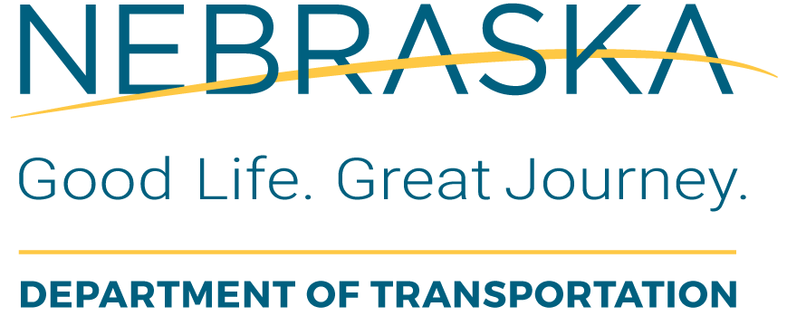 | Section 5339 Small Urban  Capital Grant Application  FY-  Bus and Bus Facilities

Transit-Related Facility

Funding is available through an apportionment from the Federal Transit Administration and administered by the Nebraska Department of Transportation. Applications can be submitted to NDOT at any time. Eligible applicants include public agencies or non-profit organizations engaged in public transportation. Prior to submitting an application, you are strongly encouraged to contact NDOT Transit Specialist at (402) 479-4674.

General Information
Legal Name of Applicant Organization:

Unique Entity Identifier (UEI)

Address (include City, State, and Zip Code):

Name of Project Director or Supervisor: | Phone No.: | Email Address:
Name of Person Preparing this Application: | Phone No.: | Email Address:
Services Generally Provided by Applicant:

Facility Project
Please describe the project, including location:

Project type: (check one)
Renovate structure Ground-up structure
COMPLETE THE APPLICATION BY SIGNING BELOW.

CERTIFICATION: I hereby certify the information in this application is accurate and, as the authorized official for this project, hereby agree to comply with all provisions of the grant program and all other applicable state and federal laws.

Applicant’s Authorized Representative |  | Title |  | Date

