Beginning in January 2025, the Nebraska Department of Transportation (NDOT) implemented updated title block requirements for road construction plan sheets, based on regulatory guidance previously issued by the Nebraska Board of Engineers and Architects (NBEA). This document provides directions for individuals preparing plan sheets, detailing the specific information that must be included in the title block to ensure compliance with NDOT standards. Required elements include:
- Sheet Number and Sheet Title text
- Control Number
- Project Number
- Project Name
- NDOT Division Name, Address, and Phone Number
- Consultant Name, Address, Phone Number, and Certificate of Authorization (COA) Number, if applicable

- Sheet Number and Sheet Title
The tables below show the standard sheet numbers, sheet title block text labels, and PDF bookmark labels for each of the different plan sheets. The sheet title block text label shall match the text label shown on the Index of Sheets. All plan sheets and the index of sheets shall be arranged in the order shown in these tables.

Plan Sheet | Sheet Number | Index Label &  Sheet Title Block Label | PDF Bookmark Label
Title Sheet | A1 | Title Page | Title
Index of Sheets | A2 | Index of Sheets | Index
Typical Cross-Sections | B1 – B… | Typical Cross Sections | Typ X-Sect
Summary of Quantities | C1 – C… | Summary of Quantities | Quantities
Summary of Soil and Materials Survey Info | D1 – D… | Summary of Soil & Materials | Soil & Mat
Aerial Sheets | E1 – E… | Aerial | Aerial
Environmental Sheets | E1 – E… | Environmental | Enviro.
Horizontal Alignment | F1 – F… | Horizontal Alignment & Orientation | Horiz Align
General Information | G1 – G… | General Information | General Info
Phasing | H1 – H… | Phasing | Phasing
Large Scale Plans:  Geometric and Grades  Joints  Drainage  Construction & Removal (separately if needed)  Erosion & Sediment Control | J1 – J… | Geometrics  Grades  Joints  Drainage  Construction  Removal  Erosion & Sediment Control | Geom or Grades  Joints  Drain  Const or Remove  Erosion Control
Utility Relocation | K1 – K… | Utility Relocation | Utility
Plan & Profile or  Plan - Plan | L1 – L… | Plan & Profile  Plan | Plan - Profile or  Plan
Traffic Plans | M1–M… | (Traffic Plan Sheet Title) | Traffic
Lighting Plans | N1 – N… | Lighting | Lighting
Intelligent Transportation System | O1 – O | Intelligent Transportation System | ITS
Landscaping Plans | P1 – P | Landscaping | Landscape
Earthwork Data Sheets | Q1 – Q… | Earthwork | Earthwork
Drainage Cross-Section Plans | R1 – R… | Drainage Cross Sections | Drain X-Sect
Bridge Plans | S1 – S… | (Bridge Title) | Bridge – SP _ – Structure Number
Bridge Special Plans | T1 – T… | (Bridge Special Plan Sheet Title) | SP _C
Roadway Special Plans | U1 – U… | (Roadway Special Plan Sheet Title) | SP _C
Reserved for other plan sections as needed | V1 – V…
Right-of-Way Plans | W1–W… | Right-of-Way | ROW
Roadway Cross-Section Plans | X1 – X… | Cross Sections | X-Sect

- Control Number
The Control Number shown on the sheet must match the control number shown in Clarity. If there are any alpha characters in the control number, these characters must be upper case. During the letting process, the control number may change if bids are rejected or if no bids are received. This change in the control number is shown on the Title Sheet only.

Example Project with Alpha Characters

Control Number as seen on Clarity

Control Number as seen on Title Sheet
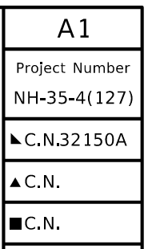

Example Project with No Bids Received and Rejected

Control Number as seen on Clarity

Control Number as seen on Title Sheet
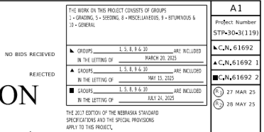

- Project Number
On Clarity, the project number has an alpha character code prior to the highway number. There could be one or more alpha character codes.
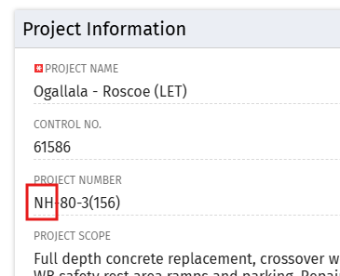

These characters refer to the funding sources for a project. During the PS&E/Letting process, the funding is prone to change, which would result in these alpha characters changing. Because of this possibility, these characters are only placed on the Title Sheet. All other sheets show the project number with these alpha characters removed, starting with the highway number. This way, if those alpha characters change, we only have to update the title sheet and do not need to update/re-sign every sheet. The only exception to this is on Local Projects.

Title Sheet: All other plan sheets: Exceptions: Local Projects

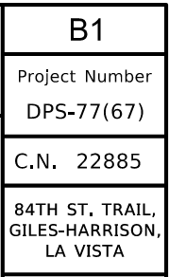
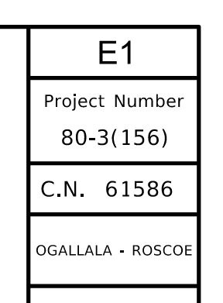
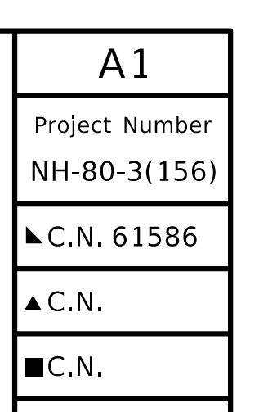

- Project Name
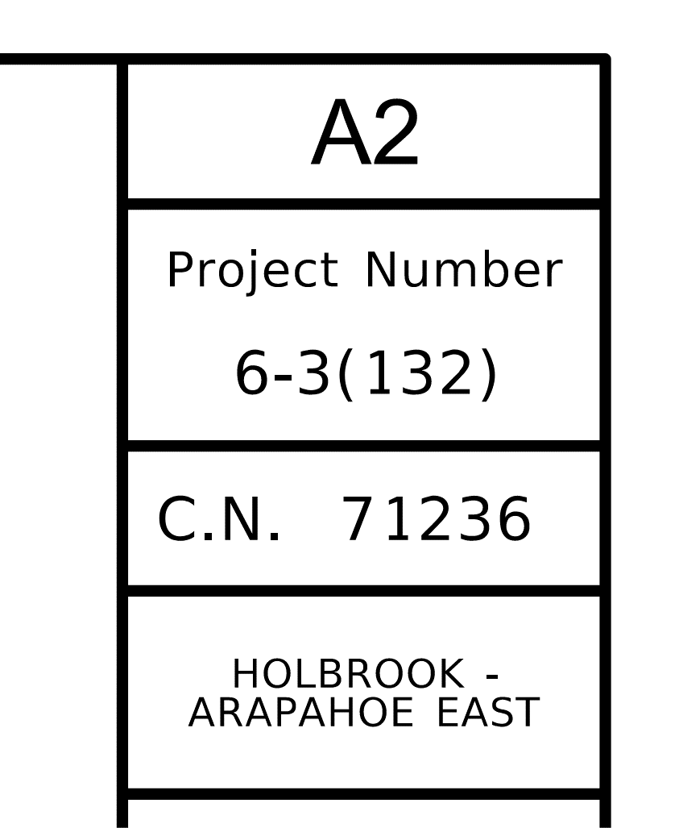
All Plan Sheets shall include the Project Name below the Control Number on the top right corner of the sheet. The only exception being the Title Sheet. This complies with the NBEA requirement to include the “Project Address or Location” on all drawings.

The project name is to match exactly what is in clarity, per character. This is to include that hyphens ( - ) are not changed to “to” or “thru/through” and ampersands (&) are not changed to “and” or vice versa. Also, all abbreviations are to be maintained when shown in Clarity as an abbreviation and all punctuation shall be included as well. (i.e. “W. Dodge Rd” to “West Dodge Road”)

The exception to this is when the project name includes a description in parentheses. The descriptor and parentheses are removed, except when the descriptor differentiates the project from another project along the same stretch of highway.

*The PDU Title Sheet info report on the NDOT Reporting Portal (see path in below image) will correctly display the Project Name.

Below are 3 example projects.

Example 1:

Clarity

PDU Title Sheet Info Report
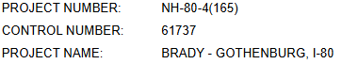

The project name shown on the plan sheets should be “Brady – Gothenburg, I-80”.
(Resurf) has been removed. The hyphen and comma are maintained.
Example 2:

Clarity

PDU Title Sheet Info Report
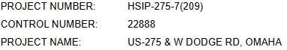

The project name shown on the plan sheets should be “US-275 & W Dodge Rd, Omaha”.
(MS) has been removed. The ampersand, comma and all abbreviations are maintained.

*************************************************************************************

Example 3:

Clarity

PDU Title Sheet Info Report
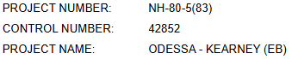

The project name shown on the plan sheets should be “Odessa – Kearney (EB)”.

On this one (EB) is included because it stands for East Bound. There is another project that has (WB) and is on the same stretch of I-80.
(MS) has been removed.

Please check Clarity and/or the PDU Title Sheet Info Report before the project name is put on the sheets. If the name is not the same on all the sheets PS&E will send back sheets and all will need to be changed and re-signed for blue line corrections.

- NDOT Division Information
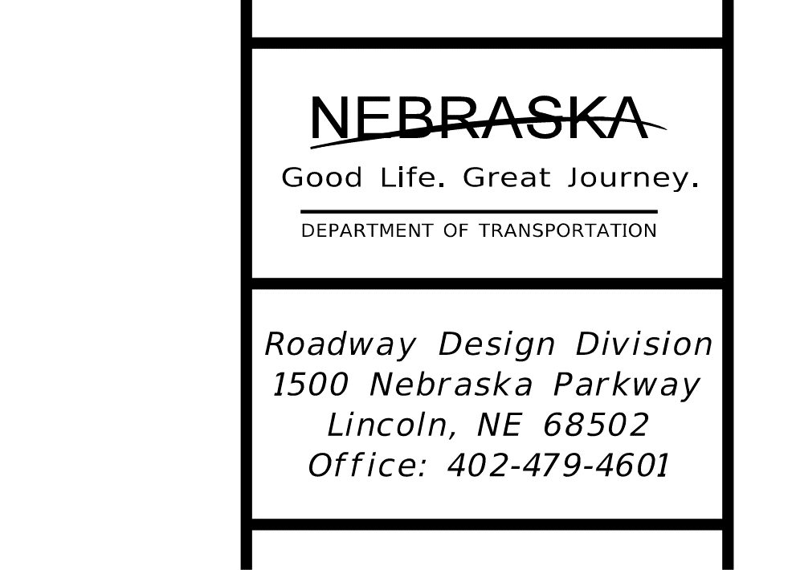
All Sheets shall include the applicable NDOT Division Address and Contact Information in the bottom right corner of the sheet. This complies with the NBEA requirement to include the “Legal Name” and “Contact Information” for the organization.

- Consultant Information
All Sheets that are designed by a Consultant organization are required to include the Consultant Legal Name, Address, Phone Number, and Certificate of Authorization number. This complies with the NBEA requirement to include the “Legal Name”, “Contact Information”, and “COA Number” for the organization submitting the plans to NDOT.
  - On Roadway Design, Traffic, or ROW plans, this information is placed in the Upper Right corner of the sheet.
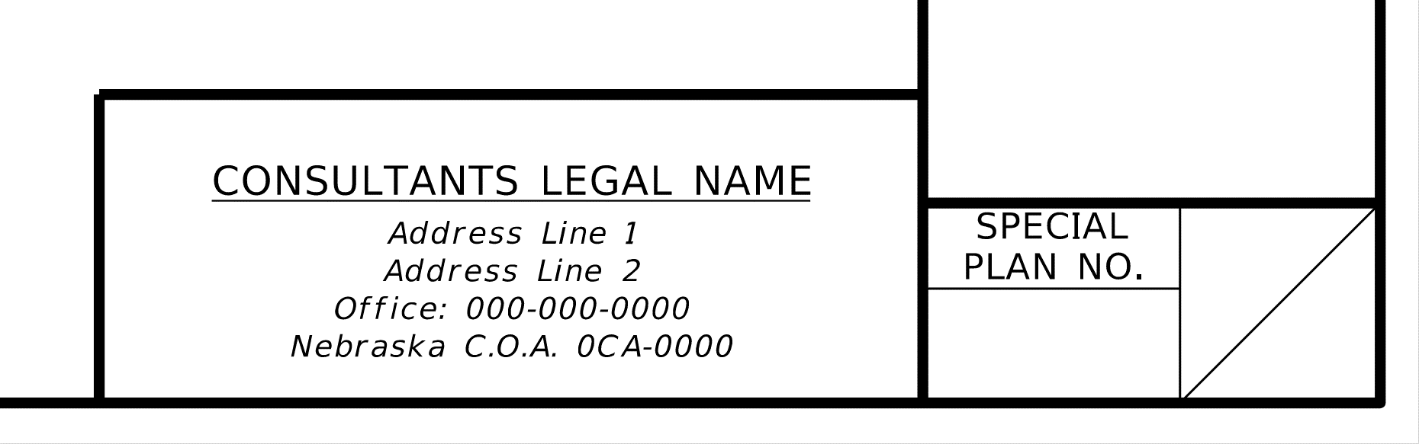
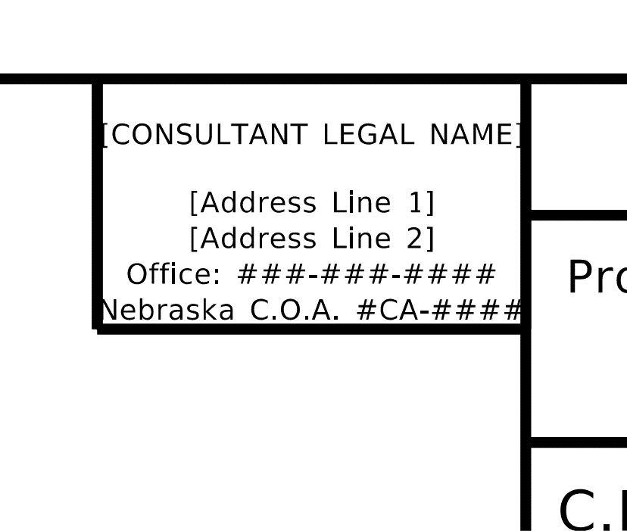
  - On Bridge plans, this information is placed in the Lower Right corner of the sheet.

